JPMC Placement Experience
Name - Nidhi Jain Contact Number - 9082671960 CGPA - 9.42 Email - nidhibafna21@gmail.com Job offered and Accepted - Yes
Basic details of the role -
❖ Company status - Dream
❖ Program - Software Engineer Program (SEP)
❖ Eligibility criteria -
➢ Aggregate CGPA should be 7 and above.
➢ No live KTs.
❖ CTC breakdown - (17.75LPA - 13+1.5+1.25+2)
➢ Fixed pay - 13L
➢ Joining bonus (one-time sign-on) - 1.5L
➢ Relocation (only if the location assigned to you is not the same as your home location) - 1.25L
➢ Incentive compensation (as per business and individual performance) - 2L ❖ Tentative joining month (may change) - June - August
❖ Students should be open for any of Bengaluru, Mumbai or Hyderabad as their location.
Timeline -
The placement process for JPMC starts during the sixth semester. The emails for the coding round and interviews were sent out in batches. Your personal mail IDs will be used for further communication between you and JPMC’s CFG team.
Event / Rounds | Mode | Platform Date
Pre-placement talk - JPMC Roadshow event | Online | Zoom March 4, 2022,  March 7, 2022,  and March 8, 2022.
Coding Round | Online | Hackerrank 18th-20th March 2022.
Interview Round | Online | Hirevue 26th March - 1st April 2022.
Shortlist Result | Online | Mail (sent by TPC) May 9, 2022
CodeForGood bootcamp or Workshops  1. GitHub Best Practices and Tips  2. Office Hours and Q&A on Code for Good  3. Presentation Skills -  How to pitch for your  final presentations | Online | Zoom - webinar  24th May - 26th May  format.  2022.  Each session is of one  hour long.
Slack invites  BeMyApp Registration invites | Online  Online | Mail (sent by the  May 25, 2022.  JPMC CFG team.)  Mail (sent by the  June 8, 2022.  JPMC CFG team.)
Team mentor huddle and Ice breaker session | Online | Zoom June 9, 2022.
JPMC CodeForGood  hackathon | Online | Zoom 11th June- 12th June 2022.
JPMC final placement results | Online | Mail (sent by TPC  July 19, 2022.  on VES mail id)

Pre-placement talk - JPMC’s Roadshow event -
This session was conducted to familiarize us with the placement process at JPMC. They provided comprehensive explanations of both CodeForGood and the hiring procedure. Throughout the occasion, the speakers (various JPMC employees across India) talked about what they did, what their role was at the company, their work culture, and how they climbed the ladder. They also revealed a lot about the qualities that an applicant should really possess. They disclose all information regarding their hiring procedures, coding challenges, hackathons, etc.
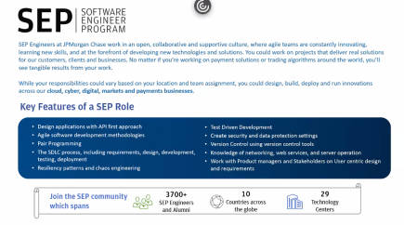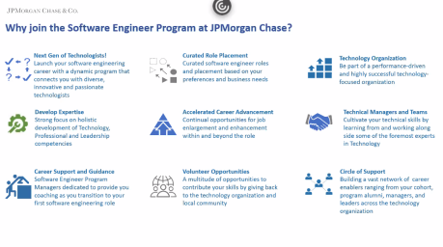
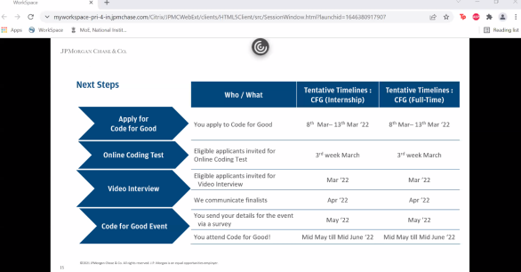Important takeaway -
Note down what the company expects from you and understand their work culture.
Coding Round - (HackerRank)
Questions asked in the coding round:-
Question 1 - Break a palindrome
A palindrome reads the same from left or right, mom for example. There is a palindrome that must be modified, if possible. Change exactly one character of the string to another character in the range asci[a-z] so that the string meets the following three conditions - 1. The new string is lower alphabetically than the initial string.
2. The new string is the lowest value string alphabetically that can be created from the original palindrome after making only one change.
3. The new string is not a palindrome.
Return the new string, or, if it is not possible to create a string meeting the criteria, return the string IMPOSSIBLE.
Example -
palindromeStr = ‘aaabbaaa’
● Possible strings lower alphabetically than ‘aaabbaaa’ after one change are [‘aaaabaaa’, aaabaaaa].
● ‘Aaaabaaa’ is not a palindrome and is the lowest string that can be created from palindromeStr.
Question 2 - Conference Schedule
A schedule has just been released for an upcoming tech conference. The schedule provides the start and end times of each of the presentations. Once a presentation has begun, no one can enter or leave the room. It takes no time to go from one presentation to another. Determine the maximum number of presentations that can be attended by one person.
Example -
n = 3
scheduleStart = [1,2,3]
scheduleEnd = [3,2,4]
Using 0-based indexing, an attendee could attend any presentation alone, or both presentations 1 and 2. Presentation 0 ends too late to be able to attend Presentation 2 afterwards. The maximum number of presentations one person can attend is 2.
What to do and what not to do in this round?
How to prep -
● Pick any one language for DSA (Java, C++, etc). You should thoroughly know the basics of the language. Master problems on stacks, queues, arrays, strings, and linked lists. (Basic data structures)
● Learn DSA, and solve a lot of problems on leetcode, hackerRank, etc. ● Randomly skim through the questions and try to understand the question, then try building the logic.
Since the coding round was conducted on HackerRank, take care of the following things - 1. Your camera must be on for the entire duration of the test. Make sure you follow all the instructions provided by the platform at the time of the test.
2. Turn on the ‘do not disturb’ or ‘focus mode’ setting of your laptop to avoid clicking out of the test screen while giving the test. Tab switching isn’t allowed. You won’t be able to give the test if you switch between the tabs.
3. Try to complete a question by clearing all the test cases. There might be a chance that you will be chosen for the next round even if you completely answer one question and then fail to code the next one or you couldn’t pass all the test cases.
4. Try your best to avoid plagiarism. Don’t give common names to your variables like ‘arr’, x, y, i, etc. Try to make your code distinctive.
Interview Round - (HireVue)
On March 28, 2022, I received an email from interviews@hirevue.com on behalf of JP Morgan Chase informing me that the next step in the hiring process would be a video interview. These emails were sent to the coding round's short-listed candidates.
You can answer up to three practice questions to understand how the platform works. As the experience will be very similar to the questions themselves, you can use these questions to possibly get yourself warmed up.
You have two chances to answer a question.
Questions asked -
1. Tell us about the specific career goals that you have set for yourself. 2. Tell us about an experience you have had, that you would describe as a learning experience. Tell us about the problem and the outcome.
Important things to remember -
● Try to answer your questions in one go, that way it will sound genuine and natural. Don’t memorize your answers.
● For your experience, preferably give an answer about where you worked on something, how you understood your project, collaborated well with your teammates, how you solved a problem, etc. Talk about tech.
● For your career goals make sure you give a logical answer and not something out of the box. For example, working on different projects, learning any specific technologies, diversifying your area of interest, etc.
● Make sure there is good lighting. Check your mic and camera before you give the interview as this is your only chance (before CFG) to be heard by the team. ● Make sure you are appropriately attired; it is recommended that you wear formal clothing.
● Look at the camera while you are talking. Make your answer crystal clear. Put emphasis on the points you think are important for them to notice.
Total shortlisted candidates for CFG - 48
INFT - 23, CMPN - 17, EXTC - 4, ETRX - 2, MCA - 2
CodeForGood Personal Experience
SGO (Social Good Organization) assigned - Connecting Dreams
Team number - 06
Team size - 8
Number of mentors assigned - 2
Result - Participation. We didn't make it through to the final round.
Timeline -
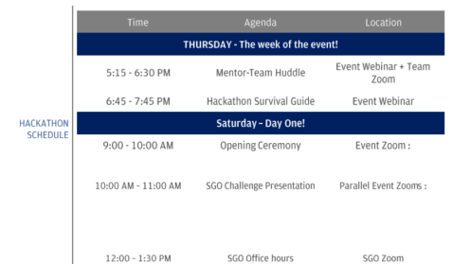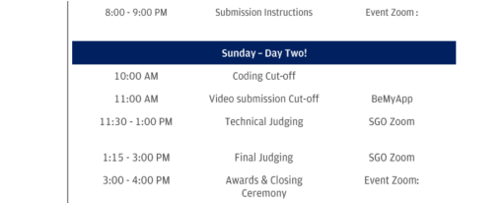
Basic details of the hackathon -
CodeForGood is how JPMC hires full-time SWE employees from our college. CFG is a 24-hour hackathon. We had to choose five problem statements and prioritize them from one to five. Your team will be assigned one problem statement from your list for which you have to develop a working solution (usually a prototype, or a complete application if possible :) otherwise, you should be clear about how your application will work).
Week of the event -
During the week of the event, you will come to know who your teammates are. It is advised that you start finding them and create your own channel in Slack. So, find your team members and create your channel/group. Before the official mentor-team huddle meeting, we had already started communicating and planning for the hackathon. Try to create a friendly environment for your team by talking to and getting to know your teammates. We then asked each other what technologies we all knew or were familiar with.
In the end, the main output from this meeting should be -
1. a comfortable environment,
2. a temporary tech stack, (you may have to add/remove certain technologies after a problem statement is assigned to you)
3. who is comfortable working on the frontend and backend,
4. any innovative functionality you can add to an application,
5. we had also arranged basic templates (sign-up, sign-in, about pages, dashboard templates, basic design templates, etc),
6. Integration between client and server is usually the same in almost all applications, so you can keep this ready for use before the hackathon starts.
Go through the problem statements that were given to previous CFG hackathons, try to design a solution, and observe your team’s dynamics. See who works well together, who is good at presenting an idea, who is good at designing, who knows a great deal about APIs, who knows how to work with machine learning and AI models, who’s good at data analytics, etc. My mentors were interested in finding out how we would reach the intended audience; in this case, my familiarity with public relations was helpful. Integrating it with the technological aspect helped me create a better impression in front of the mentors. Every small thing matters. Your mentors are curious about how your mind functions, how you approach
problems, and your level of knowledge. CFG is a 24-hour character assessment test in addition to a test of your technological knowledge.
Mentor - Team huddle -
As I mentioned earlier, my team and I had already started the fundamental planning for the hackathon. During this mentor-team Zoom call between my team and the mentors, we were able to interact and get to know one another better.
One thing to keep in mind is to always take the initiative. For instance, take the initiative to start your team's Slack channel. You should also participate actively in all discussions, create a positive atmosphere on the call, and present yourself as someone who is approachable. Our mentors made us comfortable by asking random questions like what our hobbies are, about our college, etc. After some time, they briefed us about the hackathon and solved our queries. My mentors were very sweet, and they made sure that we were all comfortable by the end of the session. We discussed our tech stack with them (we had decided to go with the MERN stack for now).
Problem statement release and allocation -
Teams were divided into two batches. Each batch received a set of problem statements. The problem statements were released in the morning by 7–7:30, and we had to submit the list of problem statements (with priority assigned) by 12 noon.
I asked my team to attend a Google meeting after receiving the problem statements so we could discuss which ones we thought were good. This helps the team since it enables us to come up with fresh solutions for each problem statement and finally choose which one to concentrate on. Before SGO presentations, you should make a basic project flow for the top 5 problem statements so that you can assess whether you are thinking in the right direction. After the SGO presentations, we had to submit our list of prioritized problem statements by filling out a survey. It is said that you should submit your list within a minute or two to have a fair chance at getting your top priority.
SGO challenge presentations -
In this meeting, pre-recorded videos of all the SGOs are presented, where they tell us about themselves and what their organization does and provide basic details about the problem statement, based on which you are supposed to decide which problem statement grabbed your attention.
After the problem statements are released and the SGOs have given you a brief idea of their problem statement, you will have to submit your preference list via a form. We were told to fill out that form as soon as possible in order to receive the problem statement of our choice (in accordance with your preference list), so we were constantly checking the link to see if it had been activated.
SGO Office hours -
SGO office hours are basically a meeting with the organization whose problem statement you were assigned. In this meeting, you can clear your doubts by asking questions to the SGO.
Once we had our problem statement, we started discussing what could be done in the application, and we started to understand the basic need of the project. But because we weren't completely confident that our understanding of the SGO's details was accurate, I suggested that all of us attend the SGO's meeting so that we could all directly understand and clear our doubts with the SGO members themselves.
Hackathon Coding hours -
Once we had our problem statement, we started discussing what could be done. The main thing to keep in mind is to understand the granularity of your problem statement and divide it into stages. Make a list of the application's most important features and rank them. For instance, priority 1 features are those that you must always code and make available first.
We created a priority list for the application's features and finalized the tech stack. Once we had a plan, we discussed it with our mentors, and they suggested some ideas too. Then we
started working as per the roles that we had assigned to each other. I was working on the front-end with two other members, and three were working on the back-end of the application.
Now it’s time for a story.
I had already checked previous React projects of mine, and they were all working fine. But, when I cloned the base project from our GitHub repository, I started getting an error. So, of course, I searched and searched for a solution and tried everything I could, but I still couldn’t solve that error. I did reach out to one of my mentors because only one is available at a time, and I also tried to tell my teammates about the problem I was facing. All of them tried to help, but nothing worked. After many tries, I took help from a friend of mine, solved the problem, and started coding.
The moral of the story is to check every single thing and keep everything ready. I had run my existing projects, and I had also created a temporary project, but I still got that error. You have to make sure that everything is working properly and that you won't face any major errors on the day of the event.
There were two team members that were not contributing significantly to the development process, and they weren’t that tech-savvy either. The six of us (three working on the front-end, including me, and three working on the back-end) got the job offer.
Important things you should remember when the hackathon starts -
1. Don’t focus on new Tech, focus on your problem statement.
2. Plan before you start coding. Plan your work, work your plan. This should be your mantra.
3. If you’re stuck, ask your teammates, ask your mentors, ask your mentors and other experts, and don’t just wait around.
4. Plan such that everyone works Parallelly, don’t go for the waterfall model 5. If you feel like giving up, Don’t, take a break and get some help after that 6. Organize your team:
a. Pick a team leader- one that settles disputes, removes roadblocks, and sets direction
b. Pick a Timekeeper – one who tracks time and the schedule
c. Regroup and do it often
d. One person can do multiple roles
e. Roles can be changed as needed
7. Define your problem (the goal isn’t just to solve the problem statement, but to show the NGOs what is possible using Tech):
8. Identify the mandatory things required to solve the challenge.
9. Identify what else can be done outside the challenge - innovativeness is a major factor for selection.
10. Keep track of what tasks are remaining, Who’s doing a particular task, and What has been done - you can use a tool to do this or you can maintain an excel sheet. 11. Try not to code little things from scratch, use online tools or templates.
One-on-One meeting with the mentor -
My mentor called me up for a one-on-one meeting to ask how everything was going and if all the teammates were performing well. He then started with some basic questions about my college. Then he started asking questions from my resume, questions like - 1. Some details about my projects.
2. Then he asked me what my role was in CSI-VESIT
3. He also asked me about my role in the VESIT Certificates team.
4. What my area of interest is? Any specific career field I am passionate about? And then he asked me to prove Why I am so much interested in that particular field? (My resume was web development and data science centric)
5. I was asked to give an example and explain how I will tackle that problem using data science and what else can I do with the help of data science.
6. I was asked to tell which of the two stages in data analysis or data science I was most comfortable in and explain it using examples.
7. Then I was asked an HR question - How would you react when there is a problem between you and some other employee?
My “interview” with my mentor was, in my opinion, pretty good as I proved my knowledge. I was unable to answer one question where he asked for a formula, but apart from that, everything went great. My meeting went on for about 20–25 minutes.
Now you just have to keep coding and testing your application and add some unique feature(s) to it. Alongside this, you should start preparing for your demo, as you have to submit a video where you or a few teammates explain the workings of your project.
The next step is the submission of your project. The management committee or the hosts will give you instructions on what to do next and how to submit your project. Follow these instructions properly. Our project had to be submitted via the website they provided.
ALL THE BEST!

